**Classification Algorithms – Confusion Matrix**

**Random Forest – Classification Report**

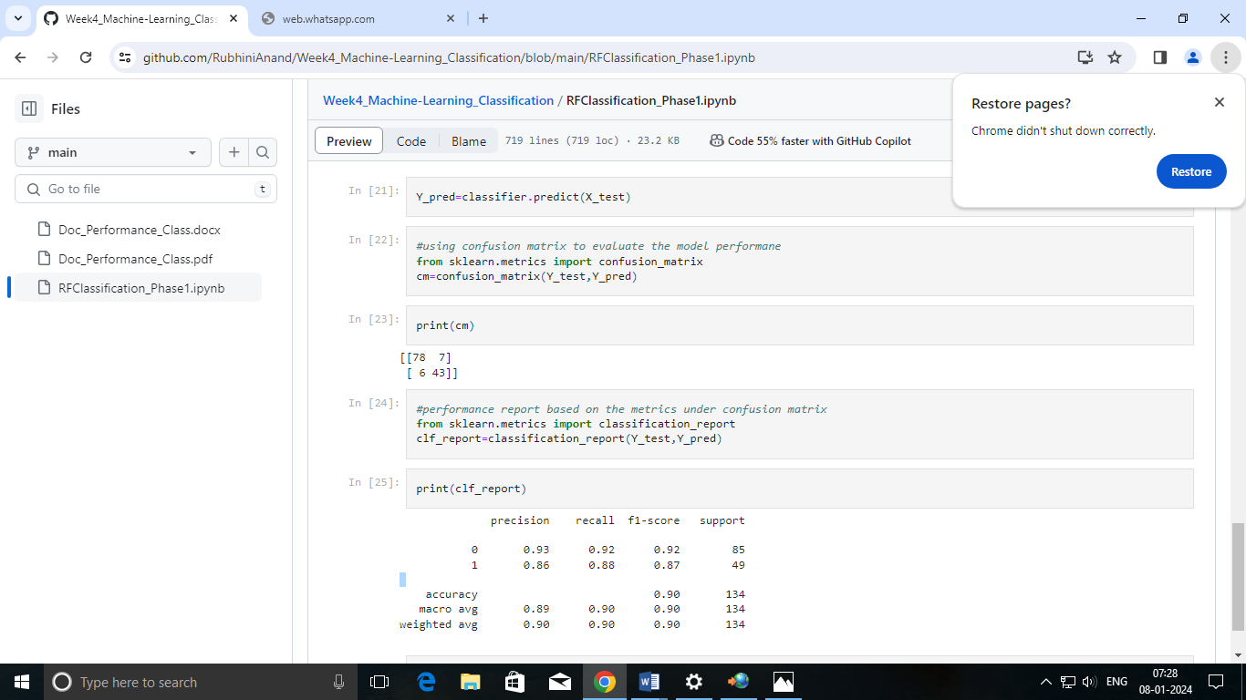

1. What is the overall performance of the model?

Accuracy is 0.90

1. What is the correct and wrong classification of not purchased?

Precision value for 0 is 0.93

3. What is the correct and wrong classification of purchased?

Precision value for 1 is 0.86

4. What is the correct classification of purchased?

Recall value for 1 is 0.88

5. What is the correct classification of purchased?

Recall value for 0 is 0.92

6. What is the overall performance of purchased?

F1-score of 1 is 0.87

7. What is the overall performance of not purchased?

F1-score of 0 is 0.92

8. What is the total number of not purchased in the test set?

Support for 0 is 85

9. What is the total number of purchased in the test set?

Support for 1 is 49

10. What is the total number of inputs in the test set?

Support for accuracy is 134

11. What is the average performance of recall, precision and f1-score?

Macro Average is 0.89, 0.90, 0.90

12. What is the proportion rate of recall, precision and f1-score?

Weighted Average is 0.90, 0.90, 0.90

**Decision Tree – Classification Report**

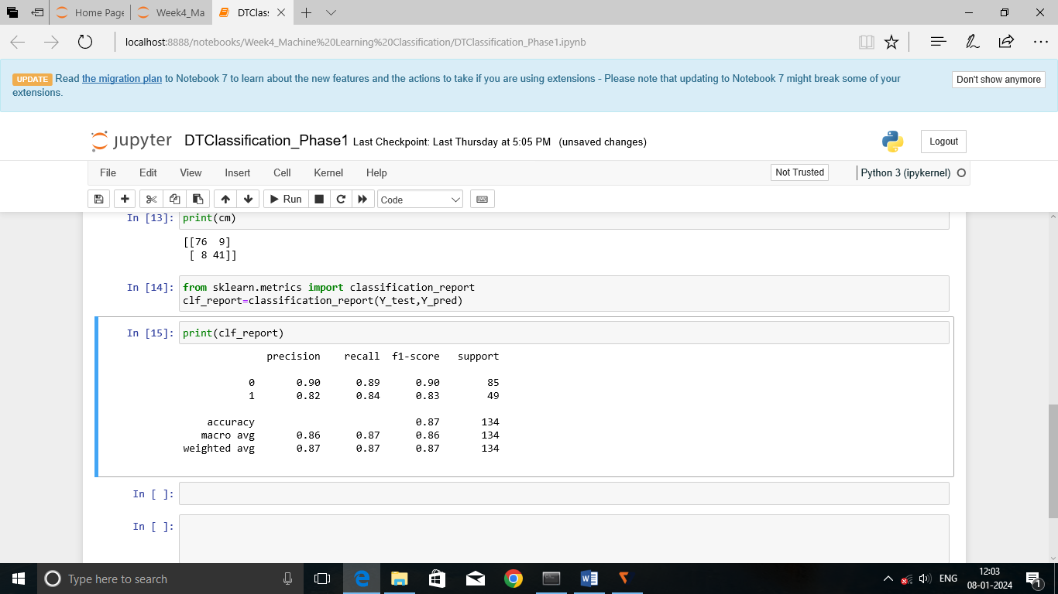

1.What is the overall performance of the model?

Accuracy is 0.87

2. What is the correct and wrong classification of not purchased?

Precision value for 0 is 0.90

3. What is the correct and wrong classification of purchased?

Precision value for 1 is 0.82

4. What is the correct classification of purchased?

Recall value for 1 is 0.84

5. What is the correct classification of purchased?

Recall value for 0 is 0.89

6. What is the overall performance of purchased?

F1-score of 1 is 0.83

7. What is the overall performance of not purchased?

F1-score of 0 is 0.90

8. What is the total number of not purchased in the test set?

Support for 0 is 85

9. What is the total number of purchased in the test set?

Support for 1 is 49

10. What is the total number of inputs in the test set?

Support for accuracy is 134

11. What is the average performance of recall, precision and f1-score?

Macro Average is 0.86, 0.87, 0.86

12. What is the proportion rate of recall, precision and f1-score?

Weighted Average is 0.87, 0.87, 0.87

**SVM – Classification Report**

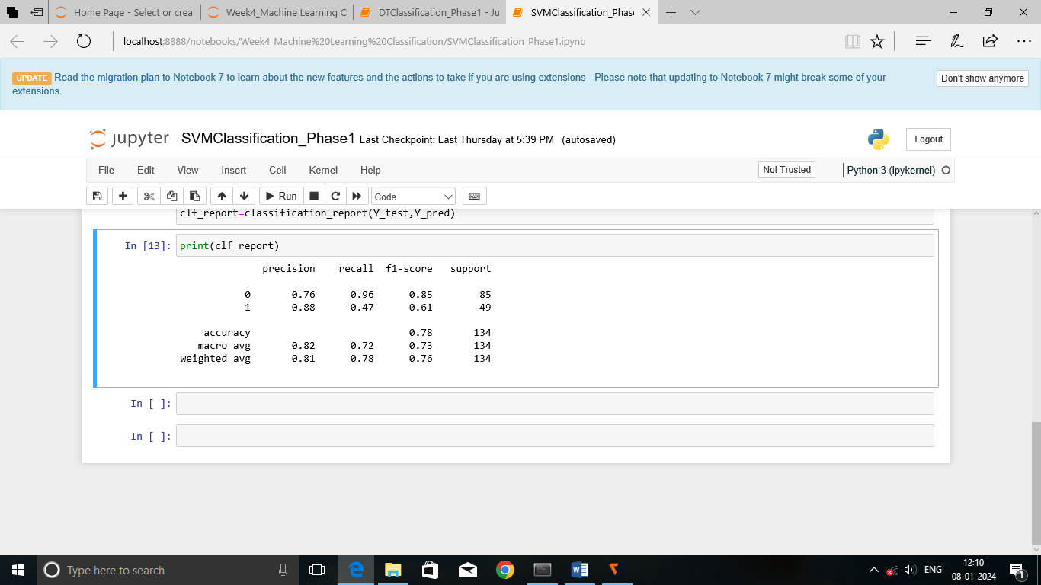

1. What is the overall performance of the model?

Accuracy is 0.78

1. What is the correct and wrong classification of not purchased?

Precision value for 0 is 0.76

3. What is the correct and wrong classification of purchased?

Precision value for 1 is 0.88

4. What is the correct classification of purchased?

Recall value for 1 is 0.47

5. What is the correct classification of purchased?

Recall value for 0 is 0.96

6. What is the overall performance of purchased?

F1-score of 1 is 0.85

7. What is the overall performance of not purchased?

F1-score of 0 is 0.61

8. What is the total number of not purchased in the test set?

Support for 0 is 85

9. What is the total number of purchased in the test set?

Support for 1 is 49

10. What is the total number of inputs in the test set?

Support for accuracy is 134

11. What is the average performance of recall, precision and f1-score?

Macro Average is 0.82, 0.72, 0.73

12. What is the proportion rate of recall, precision and f1-score?

Weighted Average is 0.81, 0.78, 0.76

# Logistic Regression – Classification Report

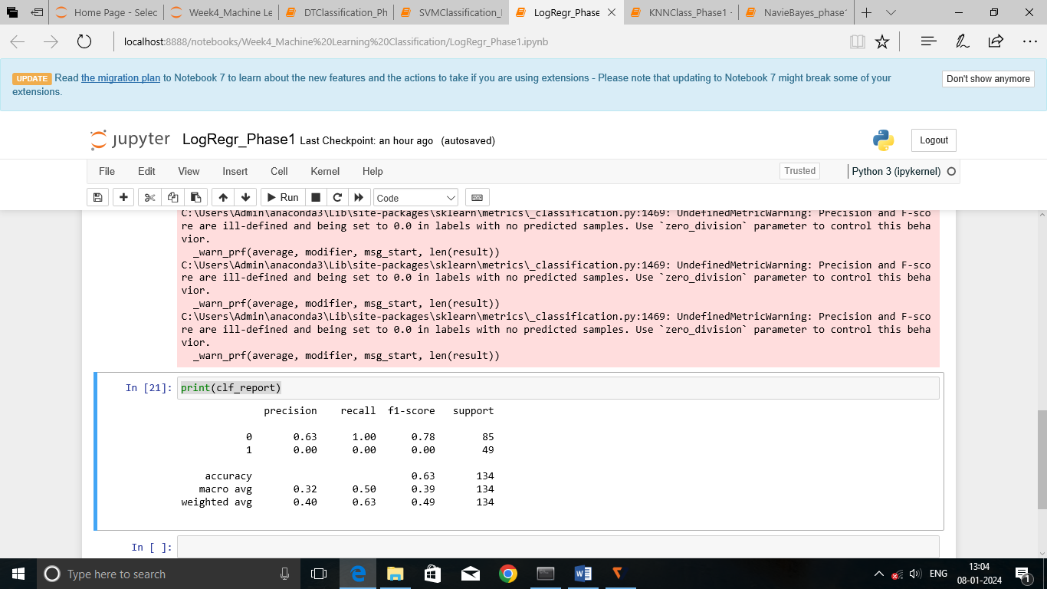

1.What is the overall performance of the model?

Accuracy is 0.63

2.What is the correct and wrong classification of not purchased?

Precision value for 0 is 0.63

3. What is the correct and wrong classification of purchased?

Precision value for 1 is 0.00

4. What is the correct classification of purchased?

Recall value for 1 is 0.00

5. What is the correct classification of purchased?

Recall value for 0 is 1.00

6. What is the overall performance of purchased?

F1-score of 1 is 0.78

7. What is the overall performance of not purchased?

F1-score of 0 is 0.00

8. What is the total number of not purchased in the test set?

Support for 0 is 85

9. What is the total number of purchased in the test set?

Support for 1 is 49

10. What is the total number of inputs in the test set?

Support for accuracy is 134

11. What is the average performance of recall, precision and f1-score?

Macro Average is 0.32, 0.50, 0.39

12. What is the proportion rate of recall, precision and f1-score?

Weighted Average is 0.40, 0.63, 0.49

**K-Nearest Neighbor – Classification Report**

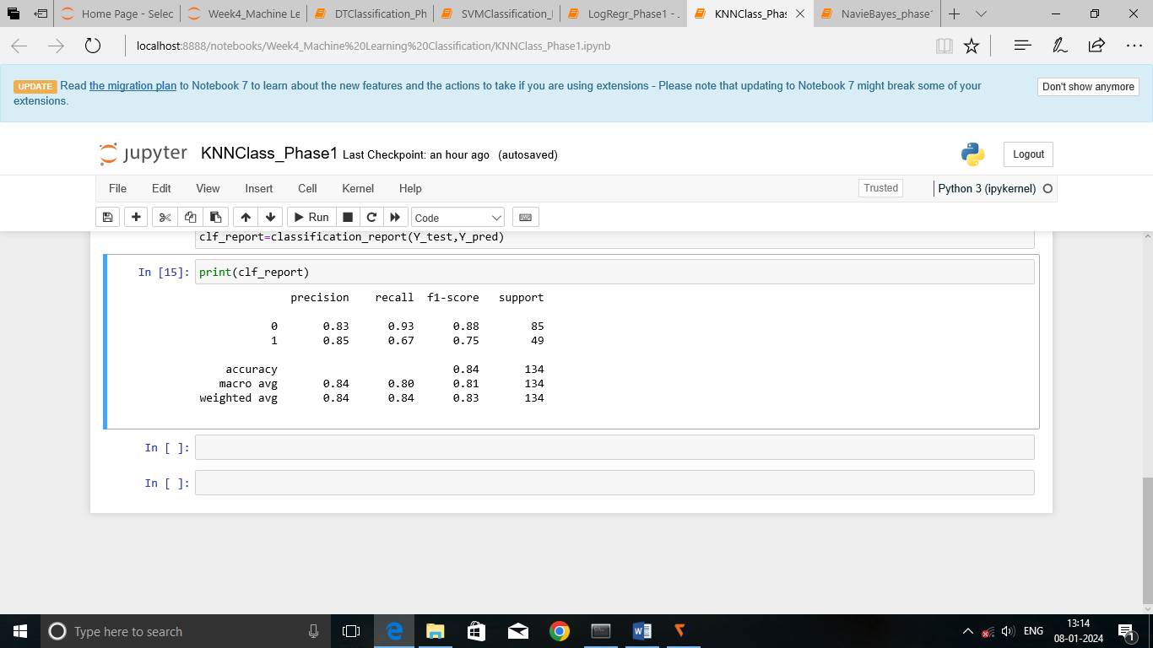

1. What is the overall performance of the model?

Accuracy is 0.84

1. What is the correct and wrong classification of not purchased?

Precision value for 0 is 0.83

3. What is the correct and wrong classification of purchased?

Precision value for 1 is 0.85

4. What is the correct classification of purchased?

Recall value for 1 is 0.67

5. What is the correct classification of purchased?

Recall value for 0 is 0.93

6. What is the overall performance of purchased?

F1-score of 1 is 0.75

7. What is the overall performance of not purchased?

F1-score of 0 is 0.88

8. What is the total number of not purchased in the test set?

Support for 0 is 85

9. What is the total number of purchased in the test set?

Support for 1 is 49

10. What is the total number of inputs in the test set?

Support for accuracy is 134

11. What is the average performance of recall, precision and f1-score?

Macro Average is 0.84,0. 80, 0.81

12. What is the proportion rate of recall, precision and f1-score?

Weighted Average is 0.84, 0.84, 0.83

**Naive-Bayes (GaussianNB) – Classification Report**

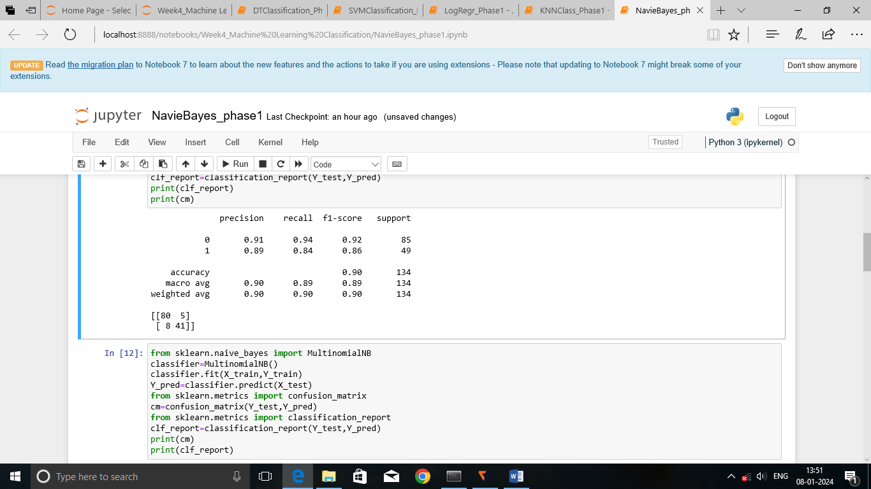

1. What is the overall performance of the model?

Accuracy is 0.90

1. What is the correct and wrong classification of not purchased?

Precision value for 0 is 0.91

3. What is the correct and wrong classification of purchased?

Precision value for 1 is 0.89

4. What is the correct classification of purchased?

Recall value for 1 is 0.84

5. What is the correct classification of purchased?

Recall value for 0 is 0.94

6. What is the overall performance of purchased?

F1-score of 1 is 0.86

7. What is the overall performance of not purchased?

F1-score of 0 is 0.92

8. What is the total number of not purchased in the test set?

Support for 0 is 85

9. What is the total number of purchased in the test set?

Support for 1 is 49

10. What is the total number of inputs in the test set?

Support for accuracy is 134

11. What is the average performance of recall, precision and f1-score?

Macro Average is 0.90, 0.89, 0.89

12. What is the proportion rate of recall, precision and f1-score?

Weighted Average is 0.90, 0.90, 0.90

**Multinomial Naïve-Bayes – Classification Report**

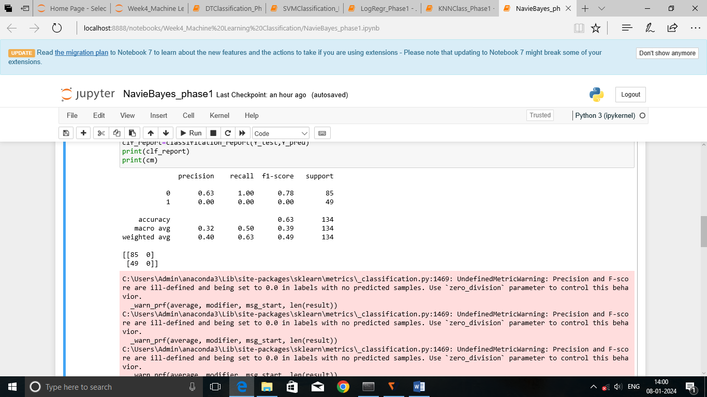

1. What is the overall performance of the model?

Accuracy is 0.63

1. What is the correct and wrong classification of not purchased?

Precision value for 0 is 0.63

3. What is the correct and wrong classification of purchased?

Precision value for 1 is 0.00

4. What is the correct classification of purchased?

Recall value for 1 is 0.00

5. What is the correct classification of purchased?

Recall value for 0 is 1.00

6. What is the overall performance of purchased?

F1-score of 1 is 0.78

7. What is the overall performance of not purchased?

F1-score of 0 is 0.00

8. What is the total number of not purchased in the test set?

Support for 0 is 85

9. What is the total number of purchased in the test set?

Support for 1 is 49

10. What is the total number of inputs in the test set?

Support for accuracy is 134

11. What is the average performance of recall, precision and f1-score?

Macro Average is 0.32, 0.50, 0.39

12. What is the proportion rate of recall, precision and f1-score?

Weighted Average is 0.40, 0.63, 0.49

**Bernoulli Navie-Bayes – Classification Report**

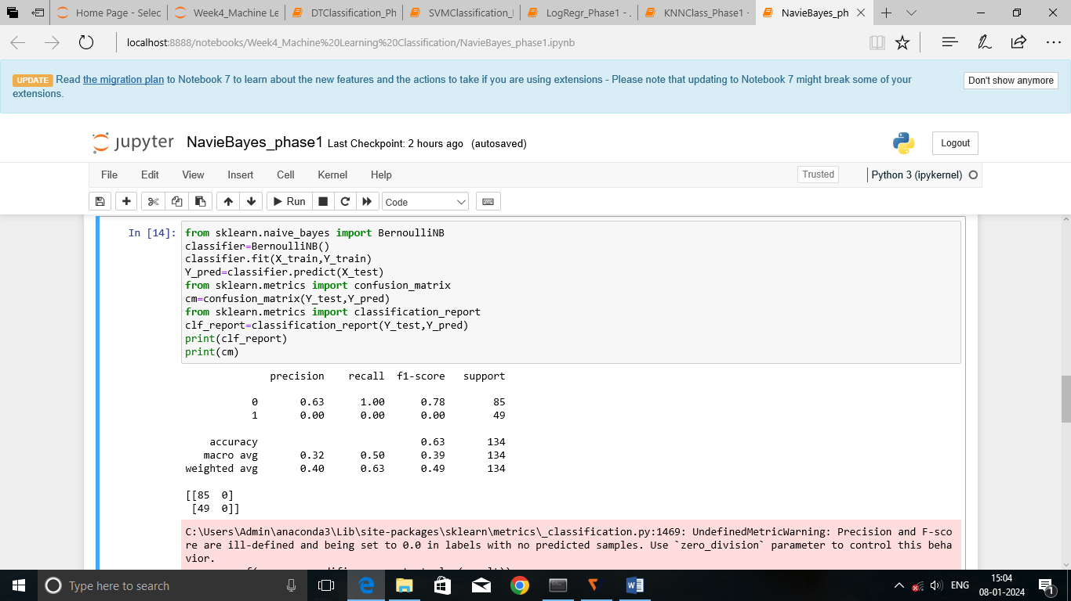

1. What is the overall performance of the model?

Accuracy is 0.63

1. What is the correct and wrong classification of not purchased?

Precision value for 0 is 0.63

3. What is the correct and wrong classification of purchased?

Precision value for 1 is 0.00

4. What is the correct classification of purchased?

Recall value for 1 is 0.00

5. What is the correct classification of purchased?

Recall value for 0 is 1.00

6. What is the overall performance of purchased?

F1-score of 1 is 0.78

7. What is the overall performance of not purchased?

F1-score of 0 is 0.00

8. What is the total number of not purchased in the test set?

Support for 0 is 85

9. What is the total number of purchased in the test set?

Support for 1 is 49

10. What is the total number of inputs in the test set?

Support for accuracy is 134

11. What is the average performance of recall, precision and f1-score?

Macro Average is 0.32, 0.50, 0.39

12. What is the proportion rate of recall, precision and f1-score?

Weighted Average is 0.40, 0.63, 0.49

**Categorical Naive-Bayes – Classification Report**

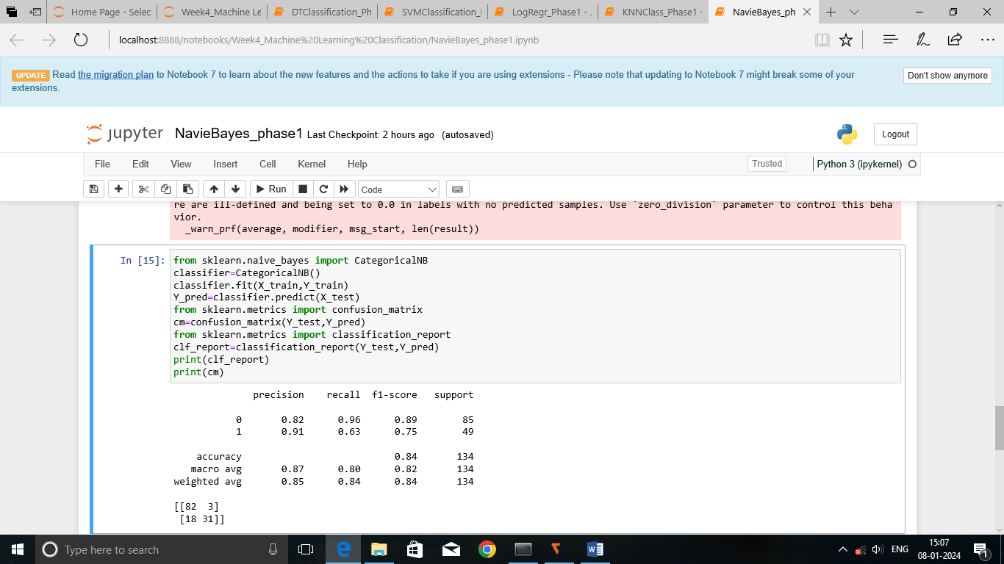

1. What is the overall performance of the model?

Accuracy is 0.84

1. What is the correct and wrong classification of not purchased?

Precision value for 0 is 0.82

3. What is the correct and wrong classification of purchased?

Precision value for 1 is 0.91

4. What is the correct classification of purchased?

Recall value for 1 is 0.63

5. What is the correct classification of not purchased?

Recall value for 0 is 0.96

6. What is the overall performance of purchased?

F1-score of 1 is 0.75

7. What is the overall performance of not purchased?

F1-score of 0 is 0.89

8. What is the total number of not purchased in the test set?

Support for 0 is 85

9. What is the total number of purchased in the test set?

Support for 1 is 49

10. What is the total number of inputs in the test set?

Support for accuracy is 134

11. What is the average performance of recall, precision and f1-score?

Macro Average is 0.87, 0.80, 0.82

12. What is the proportion rate of recall, precision and f1-score?

Weighted Average is 0.85, 0.84, 0.84

**Complement Naive-Bayes – Classification Report**

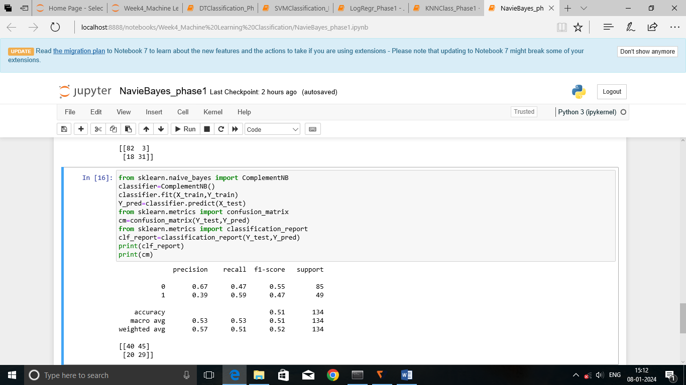

1. What is the overall performance of the model?

Accuracy is 0.51

1. What is the correct and wrong classification of not purchased?

Precision value for 0 is 0.67

3. What is the correct and wrong classification of purchased?

Precision value for 1 is 0.39

4. What is the correct classification of purchased?

Recall value for 1 is 0.59

5. What is the correct classification of not purchased?

Recall value for 0 is 0.47

6. What is the overall performance of purchased?

F1-score of 1 is 0.47

7. What is the overall performance of not purchased?

F1-score of 0 is 0.55

8. What is the total number of not purchased in the test set?

Support for 0 is 85

9. What is the total number of purchased in the test set?

Support for 1 is 49

10. What is the total number of inputs in the test set?

Support for accuracy is 134

11. What is the average performance of recall, precision and f1-score?

Macro Average is 0.53, 0.53, 0.51

12. What is the proportion rate of recall, precision and f1-score?

Weighted Average is 0.57, 0.51, 0.52